18.15: a) 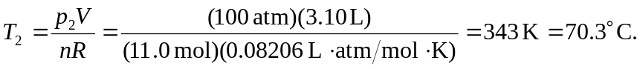
b) This is a very small temperature increase and the thermal expansion of the tank may be neglected; in this case, neglecting the expansion means not including expansion
in finding the highest safe temperature, and including the expansion would tend to relax safe standards.

